  - Implementation Approach
The [Consultant] Team’s solution for [CLIENT]’s requirements is based heavily on Commercial Off the Shelf (COTS) products. The implementation approach for a COTS implementation differs in many ways from a custom software development approach. The primary difference is that the [COTS1] and [COTS2] products that our solution brings to [CLIENT] directly address components of the foundation technologies, base applications and business solutions illustrated in the [SYSTEM] solution stack in the RFP documents. The advantages of our COTS solution are many:
- [CLIENT] users are able to see and interact with a live system with real data, helping to facilitate requirements validation, design, and testing.
- Capitalize on the lessons learned at other [CLIENT] organizations regarding what works, and what doesn’t work, in the daily operation of [CLIENT] business processes.
- Faster return on investment by avoiding a prolonged development cycle.
To capitalize on these advantages, the [Consultant] team plans to follow an implementation approach that addresses all of the components of the [CLIENT] solution in a vertical manner rather than a horizontal manner. This translates into an implementation plan that focuses on delivering the business solutions in an iterative manner. The base applications and foundation technologies required to support the business solution will also be delivered in the same iteration as the business solution. The following graphic represents our phased implementation approach:

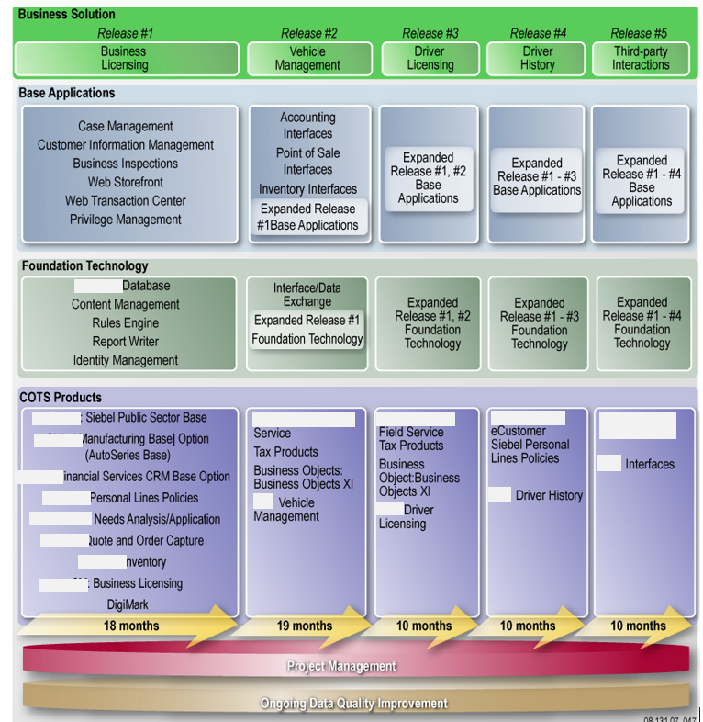

As illustrated above, we are offering an alternative approach to the implementation specified in the RFP. Our approach is based on our prior experience in the [CLIENT] domain, as well as our analysis of [CLIENT] requirements. The following table is a summary of the justification for our alternative approach:

Approach Highlight | Justification
Order of Business Solutions | - Business licensing is a discrete, relatively simple set of processes with a small amount of data relative to driver history and driver licensing.  - Business licensing is a lower risk business area, with low public visibility, allowing base applications and foundation technologies to be installed, tested, revised and proven.  - Vehicle management introduces complex historical data, but also has lower visibility than driver history and driver licensing. Vehicle management is a revenue generator and may realize a larger ROI than driver history or licensing.  - This order is optimal for achieving the goal of a common shared customer (e.g. drivers last). Data in business licensing and vehicle management typically require the most cleanup.  - The vehicle management system may provide some improvement in revenue collections earlier in the project, helping to offset project costs and demonstrate return on investment earlier in the project.
Progressive elaboration of foundation technologies and base applications | - Installation of the majority of base applications and foundation technologies in the first iteration does not imply full functionality of those components. Rather, the functionality needed to support the business solution in each iteration will be enabled, refined and implemented in the appropriate iteration.
Implementation Timeframe | - The extended timeframe addressed the risks inherent in the complexity of business processes, the magnitude of the system, and the technology transfer aspects of the project
Data Quality Improvement | - Immediate initiation of data quality improvement addresses the largest risk to successful implementation of many of the business solutions: poor historical data quality

Activities for each RUP Iteration
For each release in our implementation approach, we will structure our work activities around the four phases of the RUP process: inception, elaboration, construction and transition. The inception phase will focus on gathering a fuller understanding of the specific of the [Client] business processes and requirements for the business solution being addressed during the iteration. The elaboration phase will focus on finalizing the exact COTS products to be used to address the requirements for the business solution, and developing the proof of concept for the business solution, and the supporting base applications and foundation technologies. The construction phase will focus on modifying the COTS products to meet the [CLIENT] needs. The transition phase will consist of performing final testing on the business solution and implementing the solution into production.
Within each release for a specific business solution, the phases of the RUP approach will be iterated four times, in accordance with the development process specified in the addendum to the RFP. This iterative process will allow stakeholders to use a working prototype to finalize requirements and design, build additional functionality and modifications into the prototype, and test the prototype with real data. The following graphic illustrates this implementation approach:
Iteration 1 – Proof of Concept
Inception | - Develop a common understanding of the [CLIENT]’s vision for business solution – business processes, functional requirements, business rules  - Evaluate the technical environment and identify technical constraints  - Develop “to-be” business processes and validate functional requirements  - Finalize list of COTS products
Elaboration | - Engineer the architecture for business solution, and translate the business-focused functional requirements into detailed technical specifications  - Perform gap analysis of COTS products against technical specifications  - Develop detailed design document for integrating COTS and addressing functionality gaps
Construction | - Develop the prototype for the business solution using the selected COTS tools  - Implement revised business processes with the users who will participate in pilot testing  - Begin development of test scenarios and scripts that systematically test the functionality of the prototype
Transition | - Test business rules for business solution using pilot user group
Iteration 2 – Deployment Candidate 1
Inception | - Refine “to-be” business processes and functional requirements and design for prototype  - Address usability issues
Elaboration | - Refine detailed design document
Construction | - Transform prototype into a deployable Alpha release, focusing on high-risk processes and rules  - Assess skill level/technical competency of business solution users and begin to develop training materials
Transition | - Conduct a pilot with selected end users and evaluate effectiveness of training materials
Iteration 3 – Deployment Candidate 2
Inception | - Finalize “to-be” business processes and functional requirements and design for prototype
Elaboration | - Finalize detailed design document
Construction | - Produce the production ready version of the business solution that incorporates all required functionality and interfaces  - Conduct comprehensive testing of the integrated solution: system integration, performance and capacity, security review, and user acceptance testing
Transition | - Prepare [CLIENT] stakeholders for roll-out of business solution
Iteration 4 – Implementation
Inception | - Develop implementation plan, including pilot of final solution in an operational setting  - Develop strategic communication plan for obtaining user buy-in
Elaboration | - Finalize training materials and establish training schedules
Construction | - Perform training  - Deploy solution into production
Transition | - Monitor operation of business solution  - Compile a baseline of all artifacts required for transition to O&M and conduct knowledge transfer  - Evaluate user community acceptance and adoption (monitor Help Desk tickets and conduct post-implementation survey)

    - Pilot and Statewide Implementation
The [Consultant] team’s approach to the both the pilot and statewide implementation of the various components of the [SYSTEM] system are based on our implementation approach outlined above. Through our iterative approach, we address both the pilot and statewide implementation. The detailed activities for each release within our approach, from requirements through pilot implementation and into statewide implementation, are detailed in Appendix XXX, but our general approach to conducting pilots of functionality, and moving those pilots into a statewide implementation is outlined in this section.
Conducting Successful Pilots within the [SYSTEM] Program
The [Consultant] team’s approach relies heavily upon an iterative process in which functionality is progressively elaborated through the use of proofs of concept, pilots, and deployment candidates. To maximize the value of each iterative step of our approach, the [Consultant] team’s experience points to three key areas to be addressed during the course of customization of COTS components:
      - Building Successful [SYSTEM] Pilot User Groups
      - Creating well-defined procedures for managing each pilot
      - Rigorous and objective evaluation of pilot results

Building Successful [SYSTEM] Pilot User Groups
The [Consultant] team understands that there will be a core set of users and technical staff assigned to the [SYSTEM] project and will be co-located with the [Consultant] project team in an office environment. This core team of [CLIENT] staff will be the primary set of users and technical staff responsible for testing the deployment candidates during the pilot phases for each of the foundation technologies, base applications, and business solutions. In addition to this group of dedicated resources, the [Consultant] team will work with [CLIENT] to identify sets of users to participate in pilot activities that will enhance the value of the pilot. To maximize the value of the pilot, the [Consultant] team recommends that [CLIENT] identify pilot user groups that meet the following criteria:
- Deep experience in the existing functionality of [CLIENT] systems that is being replaced by the [SYSTEM] functionality. For instance, pilot users of the content management system should have familiarity with the existing content management system and how it integrates into [CLIENT] systems.
- Located in geographically disperse areas within the state. The pilot user groups should include staff in remote [CLIENT] locations to provide some indication of performance of [SYSTEM] system components during the pilot phase.
- Reliable availability of time to dedicate to the [SYSTEM] pilot program.
For each pilot of specific functionality, the pilot users identified by [CLIENT] that will augment the core team of [CLIENT] staff supporting [SYSTEM] will be incorporated into the training, testing, and other activities conducted during the pilot for each component of the [SYSTEM] solution.
Creating Well-Defined Procedures for Managing Each Pilot
The [Consultant] team understands that the complexity of the [SYSTEM] program, and the aggressive development schedule that requires functionality to be developed in parallel, will place a burden on the [Consultant] team, [CLIENT] personnel and the state’s Oversight Contractor to successfully manage the many moving pieces of the [SYSTEM] program. To alleviate some of this burden, as well as to ensure that the pilot of each component of the [SYSTEM] solution is successful, the [Consultant] team will utilize sound project management techniques to define procedures for conducting each pilot.
The Pilot Execution Plan will be incorporated into the overall project plan for each component of the [SYSTEM] program. The Pilot Execution Plan will detail specific information for each pilot, including, but not limited to:
- A schedule for the execution of the pilot, including start and end dates and milestones.
- A test plan and well-defined test scripts for testing the functionality of the pilot component.
- A methodology for measuring the usability of the component being examined
- A set of well-defined, measurable metrics for measuring the pilot
- A methodology for collecting metric data, such as surveys and interviews
The Pilot Execution Plan will be reviewed with [CLIENT] stakeholders prior to commencement of the pilot for a component of the [SYSTEM] solution. Once approved, the Pilot Execution Plan will be executed in accordance with the overall project plan for the [SYSTEM] component being developed.
Rigorous, Objective Evaluation of Pilot Results
The [Consultant] team will evaluate the pilot for each component of the [SYSTEM] solution using the metrics identified in the Pilot Execution Plan. Additionally, the overall effectiveness of the pilot process will be reviewed through discussion with [CLIENT] personnel to ensure that the entire process for conducting the pilot is meeting the goals of the [SYSTEM] program. The primary outcome of the evaluation of each pilot is the Pilot Results report, which will include, but is not limited to, the following information:
- Listing of defects and enhancements uncovered during testing of the software component
- Usability issues or concerns to be address in subsequent iterations
- Overall measurement of how well the solution addresses the business need
Each Pilot Results Report will be reviewed with [CLIENT] personnel prior to acceptance of the report.
Statewide Implementation Approach
The [Consultant] team’s statewide implementation approach is based on our experience delivering large information technology solutions for state Agencies, our knowledge of [CLIENT] business operations, and our understanding of the [CLIENT] and OIT technical environments. The statewide implementation approach will closely follow our overall approach to delivering business solutions. Specifically, when a base application or foundation technology has completed the pilot iterations and is ready for state-wide release, a statewide implementation plan will be developed for the discrete functionality. Based upon the specific functionality, the statewide implementation of may immediately follow the end of the pilot phase, or it may be delayed until the roll-out of the business solution for which that functionality is being developed. For example, for the content management solution, which we are proposing to develop initially in support of business licensing, may be delayed until the state-wide implementation of the full business licensing module, as the integration of the new solution with existing [CLIENT] systems may not be cost-effective, or may introduce an unacceptable level of complexity to the solution.
Whether the approach for state-wide implementation of [SYSTEM] functionality is part of a business solution release, or a discrete component, the statewide implementation plan will provide the details on managing the implementation throughout the [CLIENT] enterprise. The statewide implementation plan will include, but is not limited to, the following information:
- Help Desk Integration Plan. Prior to statewide implementation, the Help Desk staff will be given rigorous training on the functionality being implemented. Additionally, the help desk knowledge base will be updated with the most up-to-date information related to the functionality.
- Focused troubleshooting teams. To provide a consistent customer experience, members of the [Consultant] project team will be assigned to specific [CLIENT] locations to provide troubleshooting support. The [Consultant] staff will develop relationships with the points of contact at each facility throughout the course of the [SYSTEM] implementation. These relationships will facilitate troubleshooting during statewide implementation
- Intelligent scheduling of implementation. The [Consultant] team recognizes that there are certain times of the month (i.e., end of the month for inspections) and year (i.e., end of fiscal year) that introduce added complications to implementing [SYSTEM] components due to workload on [CLIENT], vacations, and throughput requirements. Working with [CLIENT] staff, we will identify the implementation timeframe that will minimize impact on [CLIENT] staff and business processes.
- Phased approach to [CLIENT] installations. The [Consultant] team recognizes that [CLIENT] locations are dispersed across the state, presenting logistical challenges to provide support to locations. To manage the workforce requirements of supporting dispersed locations, the [Consultant] team will take a phased approach to specific types of [CLIENT] installations. Specifically, during statewide implementation, we will roll-out functionality to installations in the following order:
      - [CLIENT] Corporate Offices
      - Regional Service Centers, Agencies
      - Driver Testing Centers
      - Road test facilities
      - State inspection stations
- Statewide Training Plan. A key component of the statewide implementation plan will be the roll-out of training to all [CLIENT] staff, as well as business partners and other stakeholders. The statewide implementation plan will include a statewide training plan for training staff on the functionality being implemented. The statewide training plan will focus on the types of training, the number of trainings, the schedule for training, and other components required to implement a successful training program. Please refer to Section 2.2.6 for our full training program.
    - Post Implementation Support
In support of [CLIENT]’s stated goal of supporting the [SYSTEM] system with employees of [CLIENT], the [Consultant] team is prepared to provide post-implementation support. Our support will be focused on performing knowledge transfer while also maintaining the [SYSTEM] system in good working order. Specifically, we will perform:
- System Support
- System Maintenance
- Performance Tuning
- Defect tracking and fixes
- System Enhancements
For system maintenance and support, we will perform the following activities:
- Install COTS Upgrades – System administration staff will perform COTS upgrades as needed to ensure continued effective operation of the [SYSTEM] System. System administration staff will work with [CLIENT] staff to ensure that COTS upgrades are compatible with [CLIENT]’s infrastructure and security environment.
- Conduct Periodic Security Testing – System administration staff will work with [CLIENT] and security staff to conduct security tests in accordance with the Security Plan.
- Maintain Hardware – System administration staff will work with [CLIENT] staff to maintain ERM hardware.
- Performance Tuning – Identify areas for performance improvement through load testing, and other automated means. Performance tuning can range from optimizing SQL queries to expanding available hardware
For defect tracking and fixes, and systems enhancements, please refer to Section X.X.X, for our system management plan.
Finally, as part of our post-implementation support, the [Consultant] team will also develop a Turnover Plan that will include details on the following:
- Turnover schedule
- Help desk turnover plan
- Current documentation and training curriculum
- Inventory of all work in progress
- Inventory of all equipment and software to be turned over
The Turnover plan will be drafted and vetted with [CLIENT] business and technical stakeholders prior to finalization and execution of the plan. Once approved, the turnover plan will be executed subsequent to the final acceptance of [SYSTEM] deliverables as specified in the RFP.
    - System Management
The [Consultant] team’s CMM processes provide extensive guidelines for system management. The key to our approach to system management is the establishment of a Change Control Board (CCB) for each business solution, consisting of business and technical stakeholders. The CCB will be responsible for reviewing the list of outstanding issues and feature requests, prioritizing those items, and authorizing the work to complete the fix or enhancement. The CCB will meet on a regularly scheduled basis. The CCB will be fed by a formal process of reviewing change requests submitted by users. The following is a partial illustration of the process:

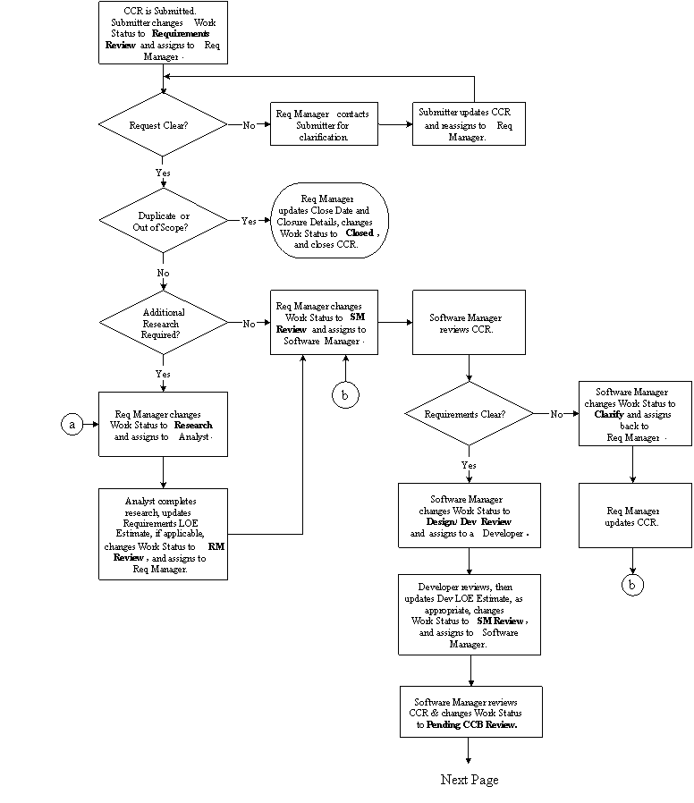

In addition to establishing the CCB, we will utilize the PVCS Tracker software for tracking the defects, enhancements requests, and other information on the state of the system. This system will be utilized to maintain the list of outstanding and completed work.

Finally, the [Consultant] team will create a New Release Plan, which will detail the processes involved in identifying the requirements for a release, as well as a schedule for releases. The following activities, among others, will be detailed in the New Release Plan:

- Identify Enhancement(s) – System administration staff will work with Help Desk staff to identify needed enhancements based on user requests and feedback. They will document these potential enhancements for CCB approval.
- Identify Defect(s) – System administration staff will work with Help Desk staff to identify system defects based on user requests and feedback. They will document these defects for CCB approval.
- Conduct CCB – System administration staff will present proposed defect corrections and system enhancements to the CCB for approval.
- Correct Defect(s) – Upon CCB approval, system administration staff will correct identified defects to [SYSTEM].
- Develop Enhancement(s) – Upon CCB approval, system administration staff will develop approved enhancements to [SYSTEM].
- Test Release – System administration staff will test defect corrections and/or enhancements included in a release.
- Update System Documentation – System administration staff will update system documentation to reflect corrected defects and system enhancements prior to their release.
- Release latest version – System administration staff will release the latest version of [SYSTEM] in accordance with approved Deployment Plan to minimize disruption to end users.

  - Deliverables
The following is a list of the deliverables and their expected due dates based upon our initial draft of a project schedule. This table contains only those deliverables required by the RFP, but the [Consultant] team will provide additional deliverables, as required by the project, throughout the course of the [SYSTEM] implementation. The following deliverable schedule is based upon an estimated start date of X.
Acceptance of Deliverables
The [Consultant] team and [CLIENT] will coordinate to develop a process for the formal acceptance of deliverables generated during the course of the [SYSTEM] program. This process will address the acceptance of well-defined deliverables such as monthly progress reports and other documents, as well the acceptance of software components of the [SYSTEM] solution. The acceptance process will include criteria for evaluating the deliverable as well as timeframes for the evaluation of deliverables. The following activities are typical, but not exhaustive, of the acceptance process performed by the [Consultant] team:
1. During the course of the project, the designated stakeholders will be consulted for answers to questions related to project execution and the final acceptance criteria. The [Consultant] team assumes that the designated [CLIENT] point of contact speaks for the entire [CLIENT] organization, and guidance provided by the point of contact is considered final.
2. The [Consultant] team will perform a system walkthrough with [CLIENT] personnel during, and at the conclusion of project activities.
3. [Consultant] will provide the 16 hours of training, and other training materials, specified in the statement of work.
4. Once successful completion of these items is demonstrated, [CLIENT] will provide final written acceptance of the products developed during the execution of this statement of work.

Deliverables Table
Line # | Deliverable | Due Date
1 | - Baseline [SYSTEM] Microsoft Project schedule
1 | - Updated project schedule and deviations at least monthly throughout the life of the project
1 | - Twice monthly Status Reports
1 | - Issue Log
1 | - Monthly Meetings and PMP Update
2 | - Quality reviews, deficiency remediation plans, meetings and schedules, as necessary
3 | - Communications Plan
4 | - Risk Management Plan
5 | - Project Management (initial)
6 | - Schedule Management Plan
7 | - Quality Management Plan
8 | Documentation Plan
9 | - Kick-off Meeting #1: Procurement Group and Project Sponsor
9 | - Kick-off Meeting #2: Senior Management
9 | - Kick-off Meeting #1: Administrator and Deputy Administrator
10 | - Use Case Scenarios and Use Case Diagrams, Activity Diagrams
11 | - Architectural Design Document
12 | - Architecture of Reusable Components
13 | - System Environment #1: development/technical test, unit test, integration, system test/UAT, production and training for the pilot phase
13 | - System Environment #2: Unit Test
13 | - System Environment #3: Integration
13 | - System Environment #4: System Test / UAT
13 | - System Environment #5: Training
13 | - System Environment #6: Production
14 | - Capacity Analysis Document
15 | - Business Continuity Plan (updates)
16 | - Disaster Recovery Plan (updates)
17 | - Security Vulnerability Assessment (OPTIONAL)
18 | - Security Vulnerability Remediation Plan (OPTIONAL)
19 | - Remediation of security vulnerability issues under the direct control of Contractor
20 | - Revised Data Models/Documentation
21 | - Revised [SYSTEM] Database
22 | - Conversion Plan
23 | - ETL Procedures
24 | - Validation Reports
25 | - [SYSTEM] Database with Converted Data
26 | - Interface Documentation
27 | - Functioning External Interfaces
28 | - Install Content Management Software
29 | - Pilot Content Management Software
30 | - Rollout Content Management Software
31 | - Production Report Analysis Document  - 33. Production reports  - 34. Ad Hoc templates (approximately 50) and the supporting runtime infrastructure  - 35. Up to 20 subject areas (universes), e.g. people, businesses, driver licensing,  - commercial driver licensing, driver testing, etc.
32 | - Install report writer software
33 | - Production reports
34 | - Ad Hoc templates (approximately 50) and the supporting runtime infrastructure
35 | - Up to 20 subject areas (universes), e.g. people, businesses, driver licensing, commercial driver licensing, driver testing, etc.
36 | - Requirements Document for Identity Management
37 | - Test software for Identity Management
38 | - Document Identity Management software
39 | - Operational Printing Subsystem
40 | - Documentation for Printing Subsystem
41 | - Data Architecture Design
42 | - Physical Data Warehouse
43 | - Physical Data Marts
44 | - ETL job streams
45 | - Documentation for Data Warehouse/Data Marts
46 | - Training for Data Warehouse/Data/Marts
47 | - Pilot Data Warehouse/Data Marts
48 | - Rollout Data Warehouse/Data Marts
49 | - Design Document for Customer Profile Management
50 | - Completed module (coded and tested) for Customer Profile Management
51 | - Documentation for Customer Profile Management
52 | - Install/implement/test Case Management sub-system
53 | - Pilot Case Management
54 | - Rollout Case Management
55 | - Design Document for Privilege Management
56 | - Completed module (coded and tested) for Privilege Management
57 | - Documentation for Privilege Management
58 | - Interface to Inventory from [COTS1] eBusiness Suite
59 | - Interface to Accounting from [COTS1] eBusiness Suite
60 | - Interface to POS
61 | - Design Document for Web Storefront
62 | - Completed Web Storefront module (coded and tested)
63 | - Documentation for Web Storefront
64 | - Design Document for Web Transaction Center
65 | - Completed Web Transaction Center module (coded and tested)
66 | - Documentation for Web Transaction Center
67 | - Design Document for Vehicle Information Management
68 | - Completed module (coded and tested) for Vehicle Information Management
69 | - Documentation for Vehicle Information Management
70 | - Requirements Document for Business Licensing
71 | - Design Document for Business Licensing
72 | - Completed Code and Unit Test for Business Licensing
73 | - Completed Testing for Business Licensing
74 | - Documentation for Business Licensing
75 | - Training for Business Licensing
76 | - Pilot for Business Licensing
77 | - Statewide Rollout for Business Licensing
78 | - Requirements Document for Driver Licensing
79 | - Design Document for Driver Licensing
80 | - Completed Code and Unit Test for Driver s Licensing
81 | - Completed Testing for Driver Licensing
82 | - Documentation for Driver Licensing
83 | - Training for Driver Licensing
84 | - Pilot for Driver Licensing
85 | - Statewide Rollout for Driver Licensing
86 | - Requirements Document for Vehicle Management
87 | - Design Document for Vehicle Management
88 | - Completed Code and Unit Test for Vehicle Management
89 | - Completed Testing for Vehicle Management
90 | - Documentation for Vehicle Management
91 | - Training for Vehicle Management
92 | - Pilot for Vehicle Management
93 | - Statewide Rollout for Vehicle Management
94 | - Requirements Document for Driver History
95 | - Design Document for Driver History
96 | - Completed Code and Unit Test for Driver History
97 | - Completed Testing for Driver History
98 | - Documentation for Driver History
99 | - Training for Driver History
100 | - Pilot for Driver History
101 | - Statewide Rollout for Driver History
102 | - Requirements Document for Third Party Interactions
103 | - Design Document for Third Party Interactions
104 | - Completed Code and Unit Test for Third Party Interactions
105 | - Completed Testing for Third Party Interactions
106 | - Documentation for Third Party Interactions
107 | - Training for Third Party Interactions
108 | - Pilot for Third Party Interactions
109 | - Statewide Rollout for Third Party Interactions
110 | - Help Desk Plan
111 | - Help Desk Knowledge Base Facility
112 | - Training Plan for State help desk employees
113 | - Help Desk staff (prior to post implementation support

