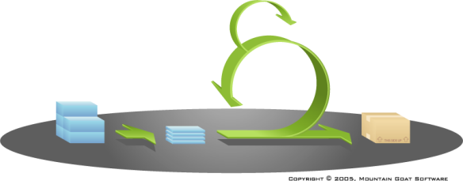
Software Engineering
Client Grading Rubric

Project Name: _________________________________________________
Team Name: ________________________

Increment Evaluations
 | How done was the increment?  (based on Acceptance Criteria & Definition of Done) |  |  | How satisfied are you with  the amount of work presented?
Sprint 1: | ☐ DONE | ☐ Conditionally DONE | ☐ Not DONE | ☐ Less than  satisfied | ☐ Satisfied | ☐ Exceeded Expectations
Sprint 2: | ☐ DONE | ☐ Conditionally DONE | ☐ Not DONE | ☐ Less than  satisfied | ☐ Satisfied | ☐ Exceeded Expectations
Sprint 3: | ☐ DONE | ☐ Conditionally DONE | ☐ Not DONE | ☐ Less than  satisfied | ☐ Satisfied | ☐ Exceeded Expectations
Sprint 4: | ☐ DONE | ☐ Conditionally DONE | ☐ Not DONE | ☐ Less than  satisfied | ☐ Satisfied | ☐ Exceeded Expectations
Sprint 5: | ☐ DONE | ☐ Conditionally DONE | ☐ Not DONE | ☐ Less than  satisfied | ☐ Satisfied | ☐ Exceeded Expectations

Legend:
DONE: Increment adheres to the agreed-upon definition of DONE
Conditionally DONE: All Sprint functionality implemented, but defects present
Not DONE: Delivered functionality not consistent with User Stories and Definition of Done

Final Product Evaluation
Evaluators, please consider:
- In your experience, to what extent does the team's product represent significant improvements over existing products?
- To what extent is the final product, as delivered, useful to the target users?
- Is the program code or product design clear enough that others would be able to replicate the team's work?

The documentation prepared by the team demonstrates they understood the client's problem.
☐ Excellent ☐ Good ☐ Acceptable ☐ Poor ☐ Unacceptable

The team delivered a solution which satisfied the problem’s specifications.
☐ Excellent ☐ Good ☐ Acceptable ☐ Poor ☐ Unacceptable

