Optimization Worksheet

Assumptions
- DB has info for just one semester, Fall 2016
- There are 25,000 sections in the DB (i.e. 25,000 rows/tuples in section)
- There are 20 buildings on campus
- Each building has 50 classrooms
- Only 5 buildings on campus have high capacity classrooms and just one such classroom per building
- Every room has the same number of sections scheduled in it (=25)
- There are 30 students in each section
- There is no short-circuit evaluation of predicates (analysis will therefore provide an upper bound)

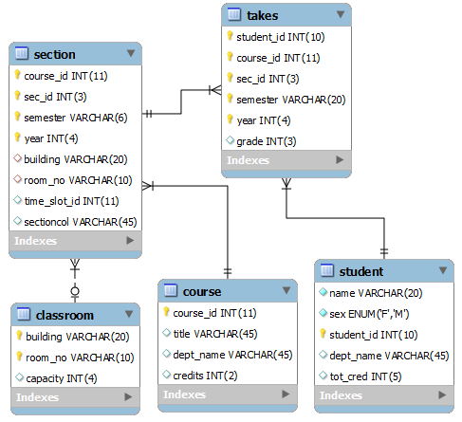

# | Contains order of operation |  | 5 | classrooms w capacity>30
 |  |  | 25 | sections / classroom
 |  |  | 30 | students / section
 |  |  | 3750 | students (takes)

Query 1:
Display how many students are taking a class in a large capacity classroom using subqueries
Query 2:
Display how many students are taking a class in a large capacity classroom using natural joins
Query 3:
Display how many students are taking a class in a large capacity classroom using no joins, but just WHERE clauses.
For these queries show the memory utilization and the processing requirements.

