Aggregation and Windows Function Practice
Chinook is a media database that resides on elvis. See (http://jackmyers.info/db/files/sql_db_creation/chinook/chinook_schema.png) for the physical data model.
For these assignments, we want to exclude any video tracks.
- Find all artists who perform in multiple genres, and list those genres by producing the table below:
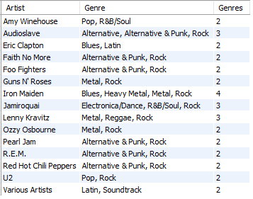

- Find all 210 tracks of Iron Maiden and order your results by the name of the song. (See the first few rows below.) However, to make the results look this way, you will need to use MySQL functions to:
  - Convert milliseconds to a more familiar minutes and seconds format, and trim leading zeroes so that we do not have times like '03:25' but rather '3:25'
  - Correct some formatting issues in the song name. Some of the tracks were uploaded from iTunes, and thus have a title such as '01 - Prowler' or '02 - Sanctuary'. These titles can be identified by looking for a space character followed by a hyphen, followed by another space. '01 - Prowler' should be retitled as 'Prowler' and '02 - Sanctuary' should be retitled as 'Sanctuary' If this is done correctly, you should see the song Sanctuary listed four times.
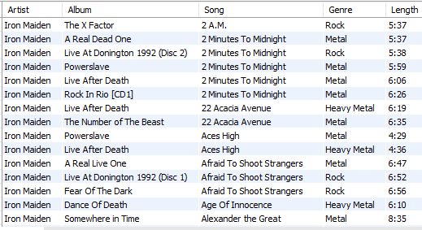

- Add to query 2:
  - The average length of all Iron Maiden songs ('Average Length for Iron Maiden')*
  - The average length per each Iron Maiden song ('Average Length per Song')*
  - Within each song, what is the rank, where ties get the same number, by length ('Rank of Songs by Length') **
  - Where does the song rank in Iron Maiden's full collection where every song gets a unique rank
('Rank of Collection by Length') **
  - The classification of song by length divided into three buckets – Short Song, Typical Song, Long Song ('Classification')
Use the NTILE function, but translate it into these bucket names.
  - How many total songs Iron Maiden has in that particular genre ('Total Songs in Genre')
* Full credit if you use length in the format of the column 'Length' – i.e., minutes:seconds format. Slight reduction if you use decimal format for length (e.g., 5.4 minutes)
** Milliseconds are way too precise for these columns. Just round to the nearest second.

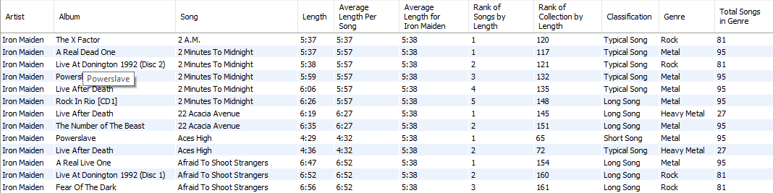
- Using query 3 as a starting point, reorder the rows by 'Length' Use the information to describe the three buckets, i.e.,
  - Short Song: between _____ and _____.
  - Typical Song: beween ______ and ______.
  - Long Song: between _____ and _____.

- Order Iron Maiden's songs by Album title, then by Song title alphabetically. When listing the songs, please indicate the previous song on the album and the next song.
