**Walking in Medford Lakes** *(this assignment is completed entirely in the SQLPlus interface of Oracle)*

1. Using the diagram of Medford Lakes (<http://jackmyers.info/db/exercises/grad/medfordlakes.pdf>),   
   create and populate the following tables in Oracle  
   1. **POI** (point of interest): store a primary key, the name of the POI, and the X, Y location
      * PJ Whelihans
      * Medford Lakes Country Clubhouse
      * the Zinc Café
      * YMCA Camp Ockanickon
      * 13 Big Chief Trail  
        *(at the intersection of Big Chief Trail and Big Look Trail)*
      * Chicagami Trailhead (80, 21)
      * Upper Aetna Lake Dam (90, 31)
   2. **Lake**: store a primary key, the name of the lake, and the lake’s geometry
      * Lower Aetna Lake
      * Upper Aetna Lake (don’t forget to account for the private island in the lake)
   3. 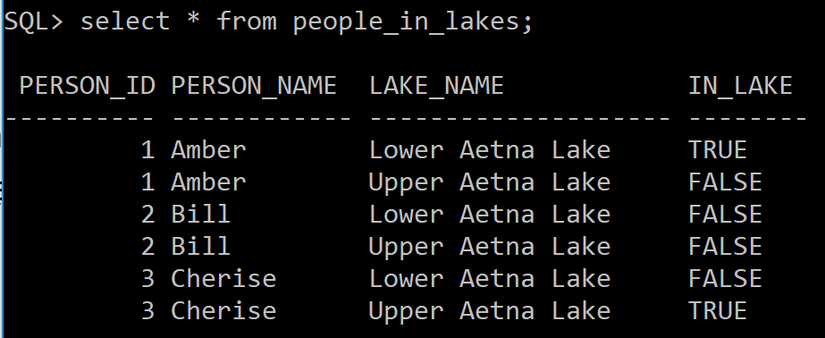**Person:** store a primary key, then name of the person and the person’s X, Y location. You can make as many people as you like.
2. Create a view, “people_in_lakes”, that shows whether all the persons are in any of the lakes. For example, see query to the right 🡪
3. 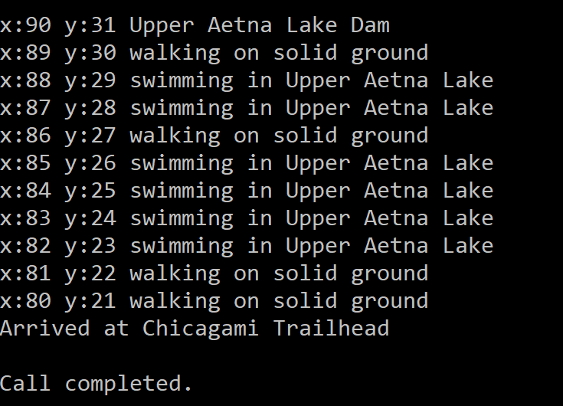Create a database function whose input is a person id, and whose output is whether or not that person is in a lake.
4. Create a person for you. Your mission is to start walking/swimming from one POI to another in a straight line by calling a procedure named move with inputs of a person id, and two poi_ids. You will place your person at the starting location then “step through” X and Y coordinates on your journey until the person is at the destination. However, you cannot move more than one unit in either the X or Y direction. (You’re not Wonder Woman or Superman.) Only integer coordinates allowed. If your journey takes you into a lake, show in which lake you are swimming.
5. What to turn in?  
   - A copy of all your code that creates and populates tables, views and indexes  
   - In the same file, a copy of the code that creates your procedure and your function.  
   - Screen shots of your journeys (please call the procedure five times for five journeys:
   1. One from the Upper Aetna Lake Dam to the Chicagami Trailhead (as shown above);
   2. One essentially heading north;
   3. One essentially heading south;
   4. One essentially heading east;
   5. One essentially heading west.