Setting up ORM for Java/MySQL
Suggested way to set up ORM for Java/MySQL.
- Use the IDE Eclipse
- In Eclipse, navigate to Help -> Install New Software.
  - Enter "http://download.jboss.org/jbosstools/neon/stable/updates/" in the Work With box.
  - Enter "Hibernate" into the filter box.
  - Select Hibernate Tools.
  - Continue to follow the wizard for installation
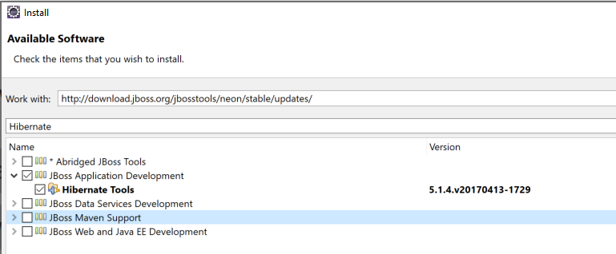
- Now you will need to go to the MySQL page and download (either install or upgrade) MySQL Connector/J -- the official JDBC driver for MySQL
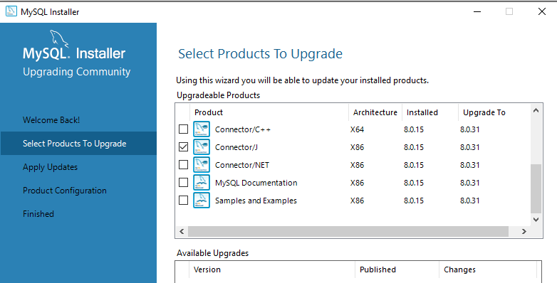

- Go to the Window → Preferences in Eclipse. Expand the Data Management → Connectivity → Driver Definitions and click on the Add button.

- In the appeared New Driver Definition dialog, select the MySQL in the vendor filter combo box and select the latest MySQL JDBC Driver from the listed drivers.
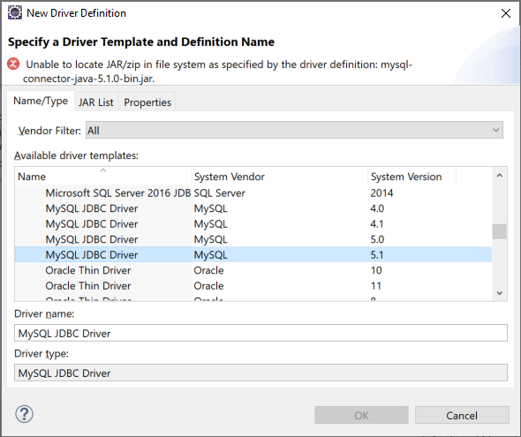
- Switch to the JAR List tab and add the mysql-connector jar.
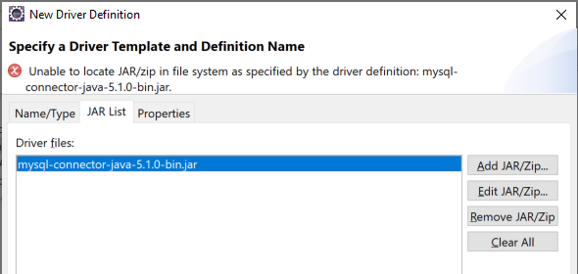
Edit the Jar and find the mysql connector jar you downloaded previously.
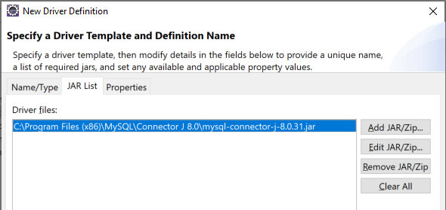
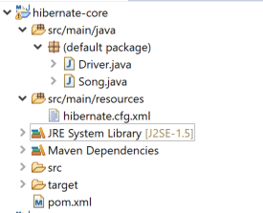
- Now make a new Maven project called hibernate-core that looks like this
The code for the two java classes and the xml files can be found here: http://jackmyers.info/db/files/orm_java_mysql/
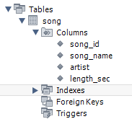
- You will need to set up MySQL (local) like this. (If you are installing MySQL locally, play attention to the wizard so that you write down your root password!)
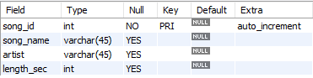
- Make sure that your hibernate.cfg.xml file properly sets up your connection to the database.
<?xml version="1.0" encoding="UTF-8"?>
<!DOCTYPE hibernate-configuration PUBLIC
"-//Hibernate/Hibernate Configuration DTD 3.0//EN"
"http://www.hibernate.org/dtd/hibernate-configuration-3.0.dtd">
<hibernate-configuration>
<session-factory>
<!-- Database connection settings -->
<property name="connection.driver_class">com.mysql.jdbc.Driver</property>
<property name="connection.url">jdbc:mysql://localhost:3306/music</property>
<property name="connection.username">root</property>
<property name="connection.password">p@ssw0rd</property>
<property name="show_sql">true</property>

<mapping class="Song" />
</session-factory>
</hibernate-configuration>
- When you can successfully run the Driver, your environment is set up for hibernate, java, jpa and MySQL.x
- --------------------------------------------------------------------------------
- Hibernate: insert into song (artist, length_sec, song_name) values (?, ?, ?)
- Hibernate: insert into song (artist, length_sec, song_name) values (?, ?, ?)
- --------------------------------------------------------------------------------
- Title: I Feel Like I'm Drowning
- Artist: Two Feet
- Length: 3:05
- --------------------------------------------------------------------------------
- Title: Under Pressure
- Author: Queen
- Length: 4:06
- --------------------------------------------------------------------------------
- Hibernate: update song set artist=?, length_sec=?, song_name=? where song_id=?
- --------------------------------------------------------------------------------
- Title: Under Pressure
- Author: Queen [feat. David Bowie]
- Length: 4:06
- --------------------------------------------------------------------------------
- Hibernate: delete from song where song_id=?

