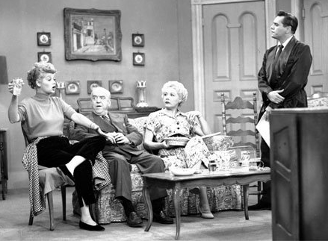
Object-Relational Mapping with Java, JPA and Oracle
“Lucy, Ricky, Ethel and Fred start a business”
(DB Topics Version)
Instructions
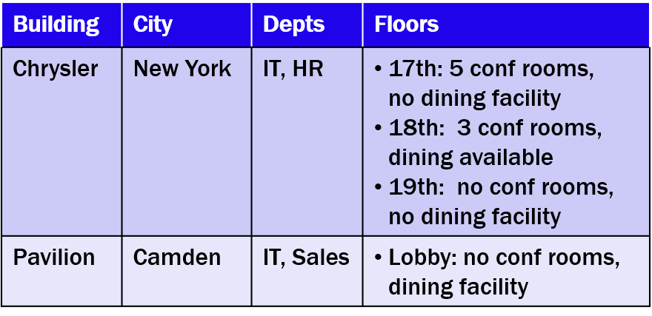
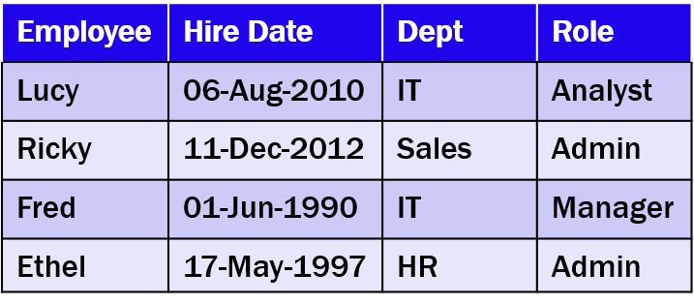
- Lucy and Ricky join Fred and Ethel in developing a building management service. Here are their roles, and information on the buildings they manage.

- Relationally, you realize this will result in the following physical data model:
Department
Employee
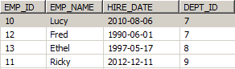
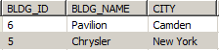
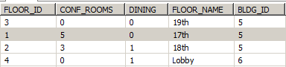
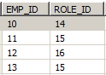
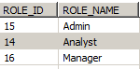
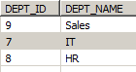
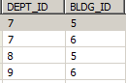
Role
Floor
Building

3. Build these classes with the appropriate JPA Annotations. Create a program to create Entities and persist the data in
MySQL.
4. Then create an SQL query to return information on each employee and what buildings they are affiliated with and
conference room information for those buildings. HINT: Remember GROUP_CONCATs and correlated subqueries.
